Q1.5 Implement the function “seqentialSearch”
Test case 02: Search number 20 in the array:

<A screenshot of a break point set up>
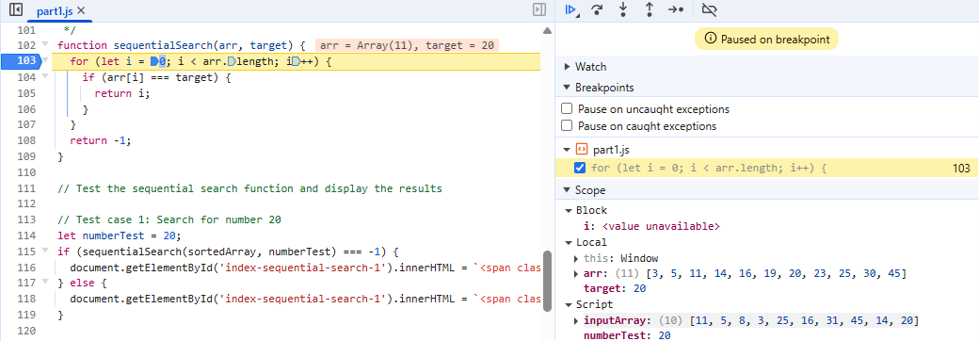
<Screenshots of a step-by-step flow of one of the functions>
i=0; check i=0 < arr.length=11
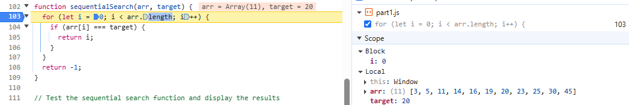
Consider if arr[0]=3 # target =20
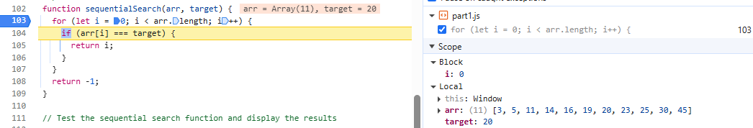

Increase i by 1 : i=1 check i<arr.length=11
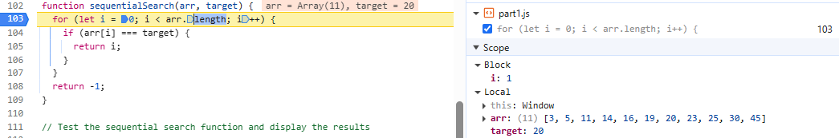
Consider if arr[1]=5 # target =20
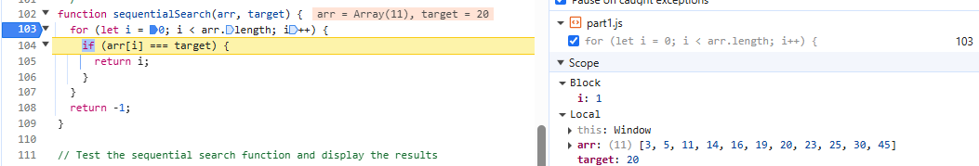
……
I=6; consider arr[6]=20 =target =20
return i=6; The number 20 is found at index 6 in the array.
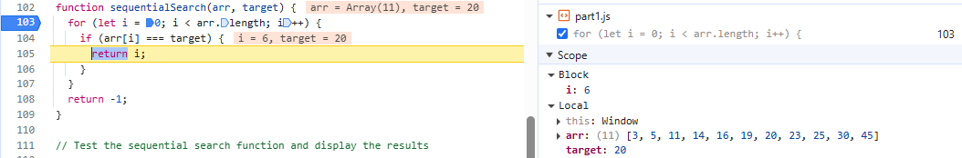

<A screenshot of variable contents>

Test case 2: Search number 4 in array. The number 4 isn’t found in the array. Return -1
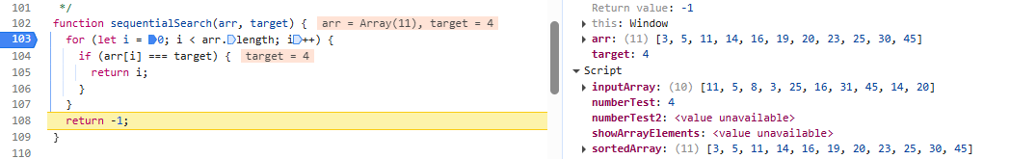

Q1.6 Implement the function “binarySearch”
Test case 1: Search number 100 in the array.
<A screenshot of a break point set up>
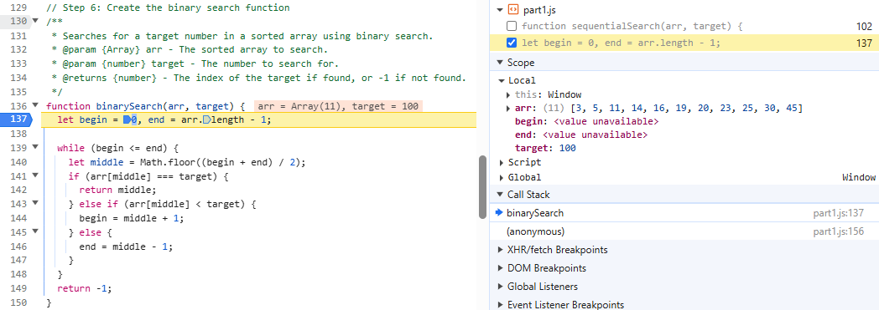
<Screenshots of a step-by-step flow of one of the functions>
begin=0; begin=0 end=arr.length-1=10. Consider begin=0 <end=10 to implement while loop
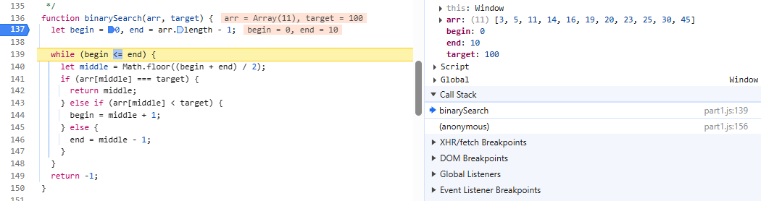

Middle=5; consider arr[middle]=arr[5]=19 < target 100
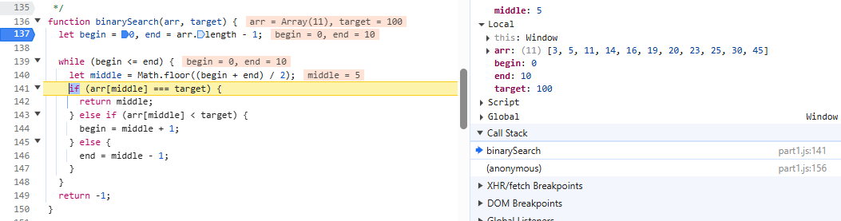

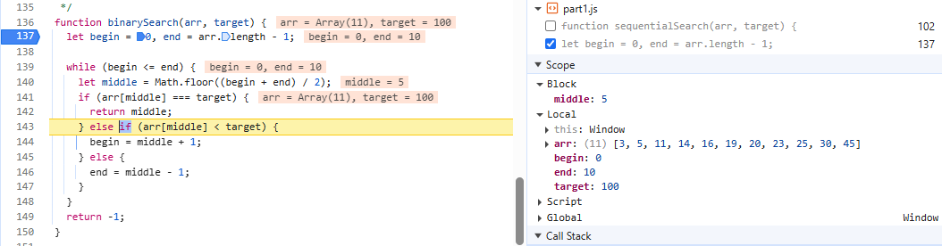
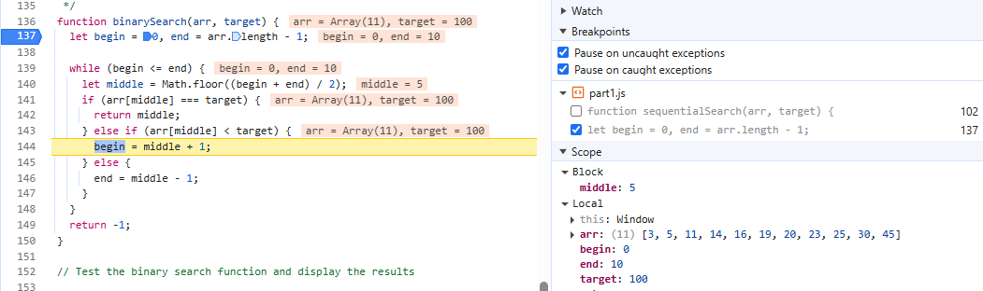
begin=middle+1 =6; end =10;
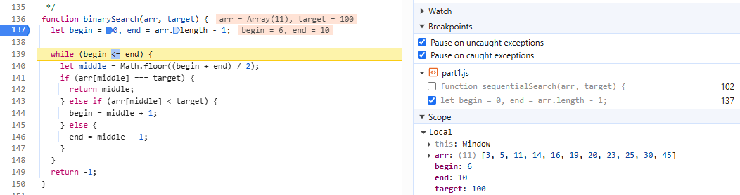
middle =8; consider arr[middle] =arr[8]=25<target =100
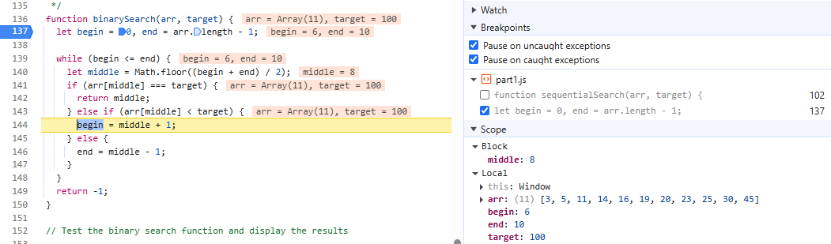
begin=middle +1=9; end =10; middle =9 consider arr[9]=30<target=100

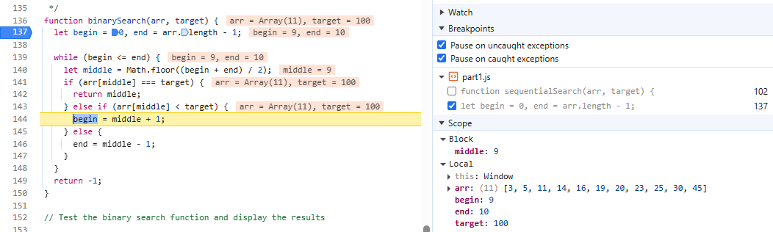

begin=middle +1 =10; end =10; middle =10 consider arr[10]=45<target=100
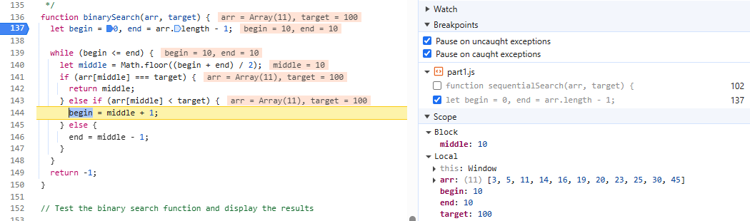
begin = middle +1=11; end =10; begin =11>end =10; return =-1;
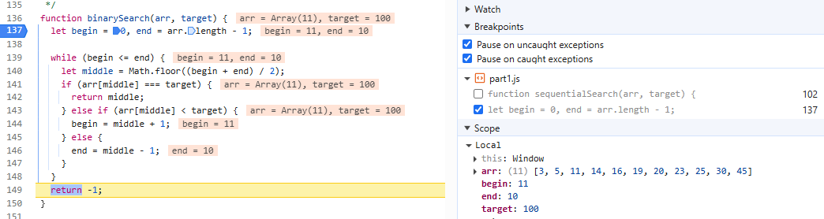

Test case 2: Search number 11 in the array.
Target =11;
Begin=0; end=arr.leng-1=10;
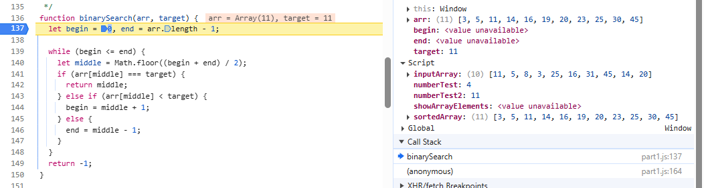
Consider begin=0 < end=10 implement to while loop
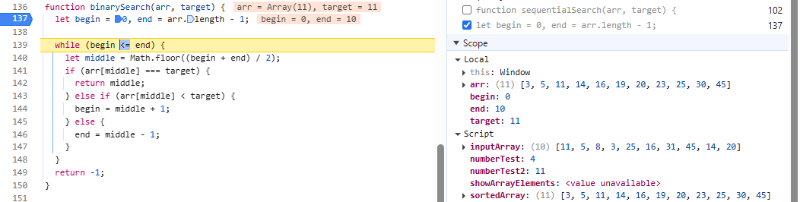
Middle =5 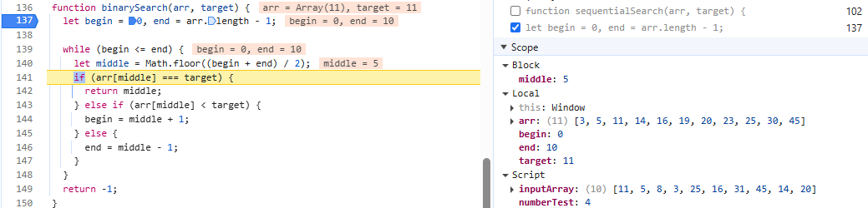
Consider arr[middle] =arr[5] =19 > target =11;
end=middle -1=4; begin =0;
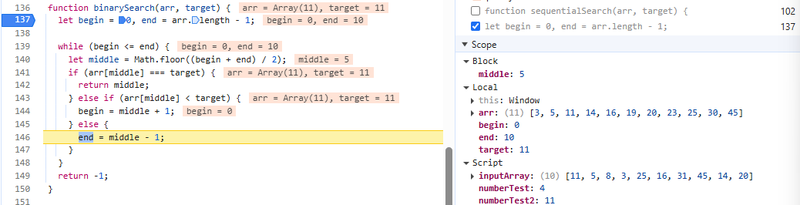
middle =2;
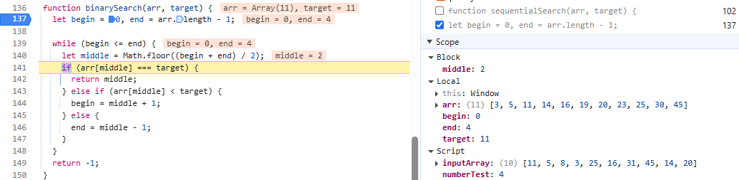
consider arr[middle]=arr[2]=11=target, return [middle]=2;

